**Elvis Jose Suazo Hernandez, 410621321**

**1. System name**

Real Estate Analyzer

**2. Motivation**

**Why do you want to develop the system?**

If one day I have enough capital, I would like to research the real estate market and invest in it. This type of investment can generate passive income.

**Why is the topic (or system) important?**

Everybody is affected by the real estate market because everybody needs a place to live. This system allows for the user to analyze the market and make informed decisions.

**3. Purpose**

To develop a system that helps the user to analyze the real estate market.

**What are the main functions are... (OR solve what problem... )**

* Display houses on a map
* Show the houses that have a higher yield/price
* Show the houses that have a higher rent/price
* Show the houses that have a higher area/rent

**4. Relative work**

**What are relative systems and their functions?**

* Get data from addresses
* Display houses on a map
* Show the houses that have a higher yield/price
* Show the houses that have a higher rent/price
* Show the houses that have a higher area/rent

**What are the differences between the related systems with yours?**

Other systems don’t tell you yield/price.

**5. System description**

**Developed packages (or modules) and tools**

Requests

Bs4

Matplotlib

Zillow API

**System functions and main techniques**

* Get data from addresses
* Display houses on a map
* Show the houses that have a higher yield/price
* Show the houses that have a higher rent/price
* Show the houses that have a higher area/rent

**Describe the process of development**

1. Investigate about Zillow
2. I tried getting home addresses from the website, but they detected that I was using special software and denied my website request. To bypass this security measure is beyond the scope of this course so I downloaded the html files manually.
3. I collected the home addresses from the html files.
4. Understand the Zillow API and how to request data.
5. Made a class to manage information well.
6. Made a list with all the requests I’ll make to Zillow.
7. Get information from 726 houses.
8. Get rental yield.
9. Display graphs.

**How many hours do you spend on this system?**

About 10 hours.

**What percentage have you developed by yourself for this system?**

About 90%.

**6. Conclusion and reflection**

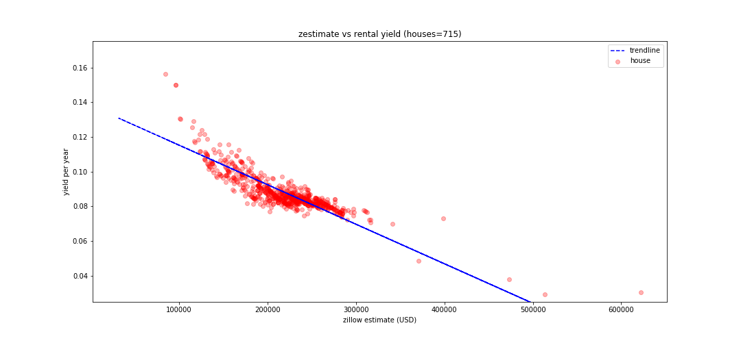

A higher investment doesn’t suggest a higher return, in fact, the opposite seems to be true. The houses above the trendline have a better performance than average from an investment’s point of view. Further analysis is required for the outliers with very good yield/price.